The Solar System
https://www.youtube.com/watch?v=h5bVZTpVxy4

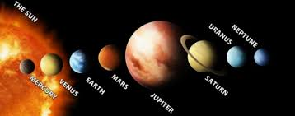
The Solar System Order (from the sun)

